NANYANG TECHNOLOGICAL UNIVERSITY
SEMESTER 2 EXAMINATION AY19-20
M6932 – “Fundamentals of Air Traffic Control”

Alternate Assessment: TAKE HOME ASSIGNMENT

Date of Release: 15 APRIL 2020 (6PM)
Date of Submission: 22nd APRIL 2020 (6PM)

INSTRUCTIONS
1. This paper consists of Eight (8) questions and comprises Eight (8) pages.
2. Answer all questions.
3. The marks are as indicated.
4. TURNITIN Report must be submitted with the paper.

QUESTION 1

- Identify the “Freedom of Air”, as defined by the ICAO, in the following cases:
  - Air Asia, a Malaysian low cost carrier, flies AA220 from Kuala Lumpur (Malaysia) to Perth (Australia) flying over Singapore.
First Freedom of the Air – airline from one country can fly over airspace of another country
  - Air Canada, a Canadian airline flies AC300 from Los Angles (US) to Chicago (US).
Eighth Freedom of the Air – right to carry cargo or passengers between two or more points in a foreign country
  - Emirates airline, a UAE carrier, flies ET502 from Dubai (UAE) to Singapore, stopping at Mumbai (India) for fuel, without loading and unloading passengers and cargo.
Second Freedom of the Air – commercial aircraft is allowed to land in another country for refueling
(6 Marks)

- A Scoot Airlines A320 departs Singapore (WSSS). The destination is Perth (YPPH). The pilot requests an initial altitude to be flown. Which of the two altitudes blow is allowed for this flight?
- 37,000 feet – Magnetic track from Singapore to Perth is between 0° to 179°, hence IFR cruising levels within the Singapore FIR given the magnetic track are odd-numbered flight levels / altitudes.
- 38,000 feet
Explain the reason for your selection.

(2 Marks)

- ATC controllers observe an aircraft flying at flight level 330 over Singapore. What is the altitude - in feet - of this aircraft above sea level? What is the general direction of this flight (i.e., North, South, East, West). Explain.

Altitude is 33,000 feet above mean sea level when the local pressure (airfield QNH) at sea level is 1013.2 hPa. General direction of this flight is either North, East, or South given FL 330 and hence magnetic track is between 0° to 179°.
(2 Marks)

(Total Mark 10)

QUESTION 2

- When the aircraft is on the ground and QNH is set on the altimeter sub-scale, the altimeter shows: (Explain your answer)
- Aerodrome elevation – Assuming altimeter is set to local airfield QNH given that aircraft is on the ground, the altimeter shows airfield altitude hence by rule of elimination, aerodrome elevation comes as the closest answer to this question.
- Zero elevation
- Transition altitude
- Isobaric level

- When the aircraft is on the ground and QFE is set on the altimeter sub-scale, the altimeter shows: (Explain your answer)
- Aerodrome elevation
- Zero elevation – Aircraft is on the ground, aircraft altimeter is set to ground QFE, altimeter reads the height above the ground, which is zero.
- Transition altitude
- Isobaric level

- What is the distance flown by an aircraft at 120 knots Ground Speed, with 10 knots head wind, in 1 hour and 45 minutes? (Show your calculations)
- 210 nm
- 192.5 nm
- 174 nm
- 159.5 nm

Time = 1 hour and 45 minutes = 1 hr + 45/60 hrs = 1.75 hrs

Ground Speed = 120 knots (Ground speed already accounts for wind)

Distance = Ground Speed x Time = 120 * 1.75 = 210 NM

- Which one of the following Air Traffic Controllers do not use Secondary Surveillance Radar? (Explain your answer)
- En-Route/Area Controller
- Approach/TMA Controller
- Tower Controller
- Ground Controller – Ground controllers do not handle aircrafts that are in the air and hence don‘t require information from the SSR which provides aircraft position and altitude.
(4 Marks each)

(Total Mark 16)

QUESTION 3
See the VFR Chart in Figure 1 and answer the following questions:
- Name and use two different methods of position fixing to locate the city Veedersburg (shown on the VFR chart, Figure 1, as black Circle) (10 Marks)

1) Position fixing using VOR-VOR
Location of city Veedersburg is on:
- Boiler VOR Radial 207°
- DANVILLE VOR Radial 138°

2) Position fixing using VOR-DME
Location of city Veedersburg is on:
- BOILER VOR Radial 207°
- BOILER DME 29 NM

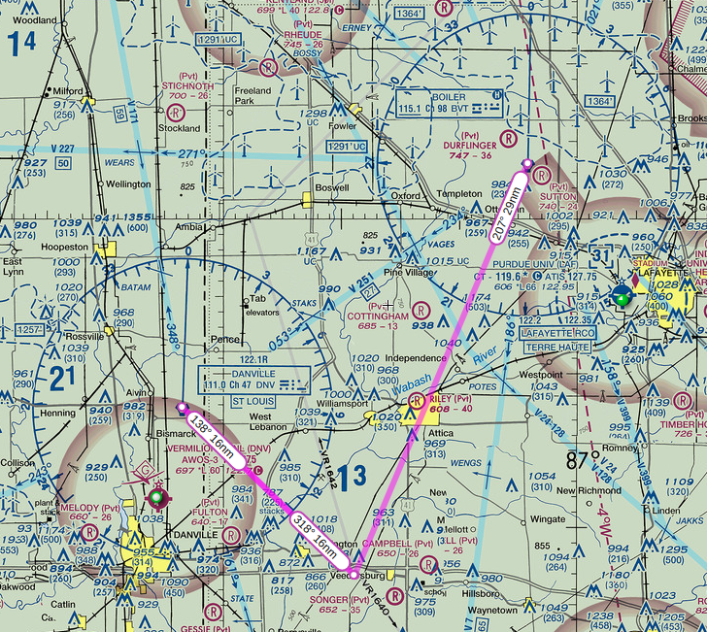

- What is the Magnetic Variance for the region depicted in the chart?
4° W (as seen on the isogonic line on the right side of the chart)
(5 marks)
- What are the approx. geographic coordinates (in degrees and minutes) for the city of Veedersburg? (5 marks)

N40°7‘ W87°19‘
(North 40 deg 7 minutes, West 87 deg 19 minutes)
Minutes rounded to nearest integer.

Notes: Use 1 minute of latitude = 1 nm
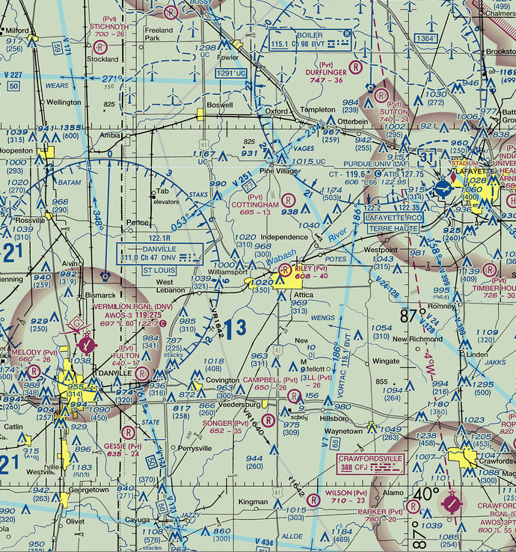
Figure 1 VFR Chart
QUESTION 4

- Each of the following coded weather reports may contain one or more errors. Most, if not all these errors, will cause a failure in the decoding, plotting, and use of the data. Determine the error(s) for each report.
- METAR OBBI 201155Z 0000KT 5SM BR BKN010 23/22 A2985
- Wind data is incorrect. First three digits should be direction to nearest 10 deg true, next two digits should be speed. 4-digit weather code given in this metar report is invalid.

- METAR OKBK 031255Z 24002KT 5SM RASH OVC040 26/17 A2999
- RASH should be SHRA to indicate showers of rain

- METAR OTBD 121955Z 00000KT 25SM 065BKN OVC100 29/20 A3045
- Missing weather code after visibility code (25SM)
- 065BKN should be BKN065
(6 marks)

- Using the ICAO Engine exhaust emissions data given below (Figure 2) and
- Compute HC emission for a Departure Procedure of a twin engine B767 aircraft using Honeywell HTF7000 engine.(4marks)
143.91g
- Compute CO₂ emission for the entire Landing Take off Cycle of a twin engine B767 aircraft using Honeywell HTF7000 engine. (5 marks)
961833.30g
Engine | Honeywell HTF7000
Mode | T/O | C/O | App | Taxi-Out | Taxi-In
EI HC | 0.05 | 0.06 | 0.12 | 1.26 | 1.26
EI CO2 (g/kg) | 3155 | 3155 | 3155 | 3155 | 3155
fuel_burn_Mode (kg/sec) | 0.347 | 0.288 | 0.104 | 0.048 | 0.048
N_eng | 2 | 2 | 2 | 2 | 2
Time_in_Mode (sec) | 42 | 132 | 240 | 1140 | 420
CO2 (g) | 91961.94 | 239880.96 | 157497.6 | 345283.2 | 127209.6
HC (g) | 1.4574 | 4.56192 | 5.9904 | 137.8944 | 50.8032
HC emission for a Departure Procedure (g) | 143.91372
CO2 emission for the entire LTO Cycle (g) | 961833.3

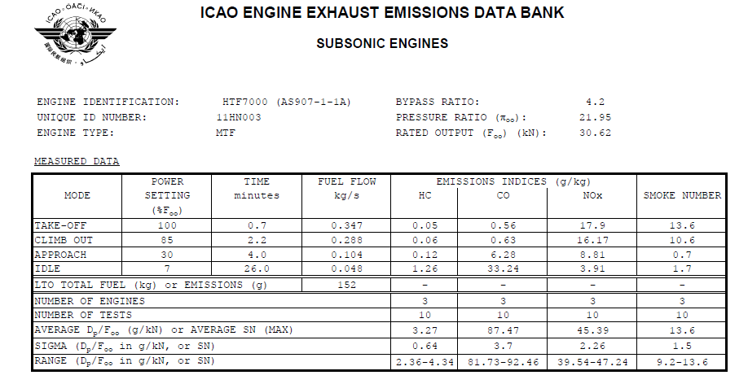
Figure 2: the ICAO Engine exhaust emissions data

(Total Mark 15)

QUESTION 5

- Read the paper about CDA approaches by Richard Coppenbarger et al. (Journal of Aircraft, Volume 46, 2009) (http://www.aviationsystemsdivision.arc.nasa.gov/publications/2009/AIAA-39795-675.pdf) and comment on the possible fuel savings
reported in the literature using Continuous Descent Approaches.
(5 Marks)

OTA1 provide an average of 242 lb of fuel savings per flight under light-congestion traffic conditions for B777 flights over baseline operations. This suggests potential fuel savings under light-congestion traffic conditions.

Average of 358 lb and 3219 lb of fuel savings per flight under medium and heavy-congestion traffic conditions over baseline operations respectively. This suggests potential fuel savings under medium and especially heavy traffic conditions.

- Read Chapter 1 of the Instrument Procedures Handbook (http://www.faa.gov/regulations_policies/
handbooks_manuals/aviation/instrument_procedures_handbook/). Briefly answer the following:
a) Define what is required navigation performance (RNP).

RNP is a group of specifications under Performance Based Navigation. It allows aircrafts to fly on a dedicated flight path with high level of accuracy, and the ability to track the aircraft positions with accuracy and integrity.

b) What is the typical RNP in the enroute and terminal airspace today in the NAS?

RNP 1

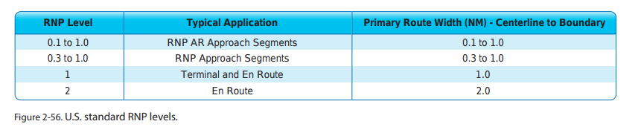
Other levels of RNP may also be use by ICAO, other states and FAA. For example, RNP 0.3, RNP 2 and Advanced RNP are used in some terminal and enroute phases as listed here (slide 3) https://www.faa.gov/about/office_org/headquarters_offices/avs/offices/afx/afs/afs400/afs410/media/nas.pdf

c) Define what is a Standard Terminal Departure procedure.
(5 Marks)

A departure route requested by ATC typically used in busy terminal areas with the goal of expediting safe and efficient flow of air traffic through dedicated phraseology that allows ATC and aircrew to communicate and understand detailed clearance information with minimal transmission.

(Total 10 marks)
QUESTION 6

Use Schmidt’s controller workload model to compute the Control Difficulty Index from the given data (Table 1) for a given Sector. Show all your calculation and formula used.

The technique Schmidt used to measure complexity was called the Control Difficulty Index (CDI). This index was calculated by multiplying a weighting factor (based on the task execution time) by the expected number of events occurring per hour.

The CDI is expressed as CDI = where

- CDI = control difficulty index,
- W_i = weighting for event I (based on task execution time)
- E_i = expected number of type i events per hour.

CDI =
= 1*6 + 0.8*4 + 0.6*20 + 0.5*0 + 0.4*25 + 0.2*12 + 0.1*5
= 34.1

Table 1: Execution time/Weighting and frequency of observable tasks
Event | Event Weighting (based on Task Execution Time) | Events/Hour
Preventing a crossing conflict | 1 | 6
Preventing an overtake conflict | 0.8 | 4
Handoff | 0.6 | 20
Pointout | 0.5 | 0
Coordination with other ATCs | 0.4 | 25
Pilot requests | 0.2 | 12
Traffic structuring. | 0.1 | 5

(Total 10 marks)

QUESTION 7
The figure below depicts a TCAS display with resolution advisory. Based on the information displayed on TCAS, answer following questions.

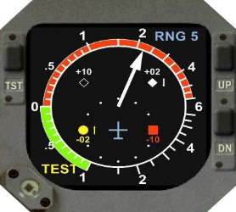
Figure 3: TCAS Display with Resolution Advisory

- Which symbol is “Proximate Traffic” and explain its features/characteristics?


Any target less than 6 nautical miles in range and within +-1,200 feet vertically, but doesn’t meet the criteria of an intruder or threat. Displayed as a filled diamond.

- Which symbol is “Other Traffic” and explain its features/characteristics?



Any target that is beyond 6 nautical miles and 1,200 feet. Altitude unknown. Displayed as an open diamond. Recommended to assist the pilot in visually acquiring the intruder causing the RA or TA.

- Which symbol is “Intruder Traffic” and explain its features/characteristics?



A filled amber or yellow circle is used to display intruders that have caused a TA to be issued. Indicates that an aircraft is a potential threat, RA may be necessary w/in, approx, the next 25 sec.

- Which symbol is “Threat” and explain its features/characteristics?



A filled red square is used to display intruders that have caused an RA to be issued. Indicates that an aircraft is a threat, accompanied by a recommended vertical maneuver.

- Explain the Resolution Advisory.

An indication given by TCAS II to a flight crew that a vertical maneuver should, or in some cases should not, be performed to attain or maintain safe separation from a threat.

2 Marks each
(Total 10 marks)

QUESTION 8

What is communicated in each ATC message? Provide a written explanation

- King Air seven-seven, fly runway heading, intercept radial three-two-zero Boler VOR

Fly runway heading: Fly the heading that corresponds with the
extended centerline of the departure runway
Intercept: To track to and then turn onto a given course
VOR: Very High Frequency (VHF) Omni-Directional Range, a type of short-
range radio navigation system for aircraft to determine bearing (direction
from the ground radio beacon in relation to Magnetic North).
Boiler VOR: A VOR station (ground radio beacon) named Boiler
Radial: Bearing from VOR station to receiver relative to magnetic North. This line of position is called the VOR “radial”.
Meaning: King Air 77 to fly on the departure runway’s extended
centerline heading towards radial bearing 320 of Boiler VOR station

- King Air four-pappa-alpha, report crossing Danville one-two-seven radial, three six mile fix

Meaning: King Air 4PA to report back to ATC upon crossing a point that is 36 miles away from Danville with respect to radial bearing 127

- United seven-seven, hold northwest of the Boiler VOR on the three-two-three radial, expect further clearance at one-two—five zulu
(3 Marks each)

Holding: A maneuver designed to delay an aircraft already in flight while
keeping it within a specified airspace.
Hold Northwest of Boiler VOR on 323 radial: The hold itself will be to
the Northwest side of Boiler VOR, 323 deg radial is the inbound leg of
Boiler VOR. Since no turns are specified in the instructions, right turns are implied (right turns are standard in a hold)
Expect further clearance at one-two-five zulu: While holding, pilot
should expect further clearance at time UTC 0125
https://cdn.shopify.com/s/files/1/0556/5101/files/Holding.pdf

(Total 9 marks)

----------------------THE END-----------------------

